File Pointer
# Source: AI Source: Provided by: [Data Path: Persons Table -> ID Column: 1, Name_En Column: Motasem Essam] -> From: [Chatgpt (GPT‑5 Mini)] on [12/10/2025]
In computing, especially in programming, a file pointer is a special marker that keeps track of your current position inside a file. It tells the computer where the next read or write operation will happen.

Definition:
# Source: AI Source: Provided by: [Data Path: Persons Table -> ID Column: 1, Name_En Column: Motasem Essam] -> From: [Chatgpt (GPT‑5 Mini)] on [12/10/2025]
  - A file pointer is not the file itself, but a pointer/marker that moves through the file as you read or write data.
  - It’s like a bookmark in a book: it shows where you are currently reading or writing.

How It Works:
# Source: AI Source: Provided by: [Data Path: Persons Table -> ID Column: 1, Name_En Column: Motasem Essam] -> From: [Chatgpt (GPT‑5 Mini)] on [12/10/2025]
  - When you open a file, the file pointer is usually at the beginning of the file.
  - Reading a file moves the pointer forward automatically as data is read.
  - Writing to a file writes at the pointer’s current position and may move it forward.
  - You can also move the pointer manually to a specific position in the file using functions like fseek() in C or seek() in Python.

Example in Python
# Source: AI Source: Provided by: [Data Path: Persons Table -> ID Column: 1, Name_En Column: Motasem Essam] -> From: [Chatgpt (GPT‑5 Mini)] on [12/10/2025]
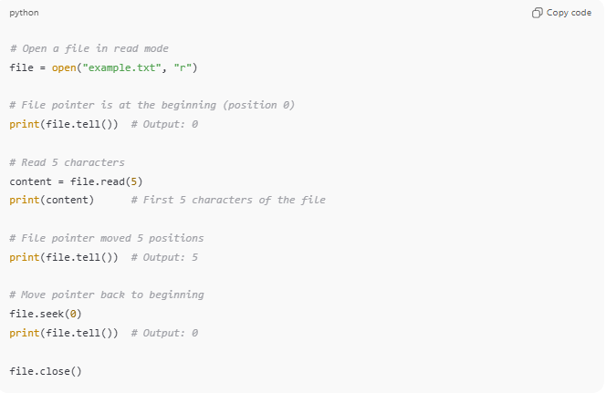
# Open a file in read mode
file = open("example.txt", "r")

# File pointer is at the beginning (position 0)
print(file.tell()) # Output: 0

# Read 5 characters
content = file.read(5)
print(content) # First 5 characters of the file

# File pointer moved 5 positions
print(file.tell()) # Output: 5

# Move pointer back to beginning
file.seek(0)
print(file.tell()) # Output: 0

file.close()
- tell() → Shows the current position of the file pointer.
- seek(position) → Moves the file pointer to a specific location.

Analogy
# Source: AI Source: Provided by: [Data Path: Persons Table -> ID Column: 1, Name_En Column: Motasem Essam] -> From: [Chatgpt (GPT‑5 Mini)] on [12/10/2025]
- File → A book
- File Pointer → A bookmark showing where you are in the book
- Reading/Writing → Reading or writing at the bookmark’s position

